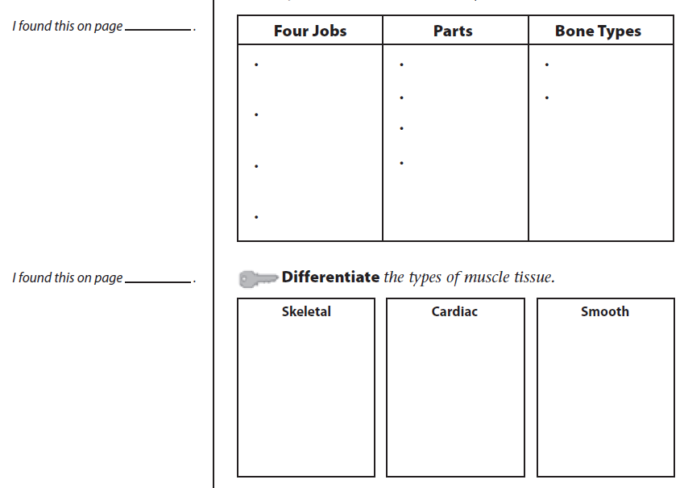
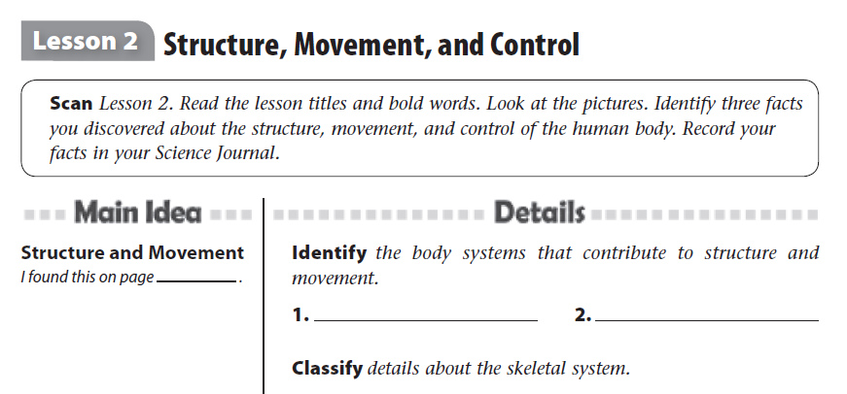

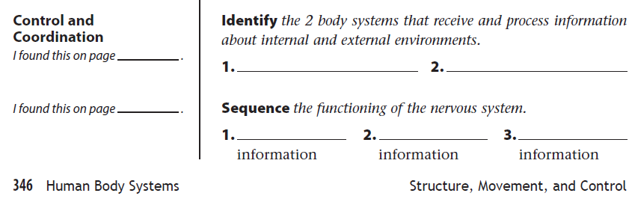

Musculoskeletal (cont’d)

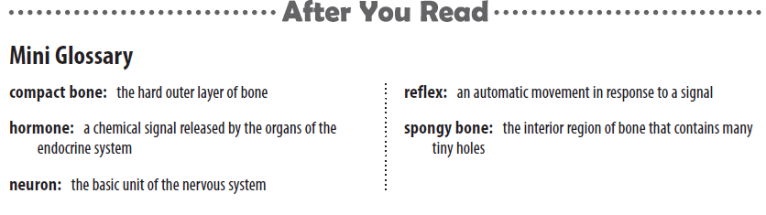

Fill in the graphic organizer below showing the four major jobs (functions) of the skeletal system.

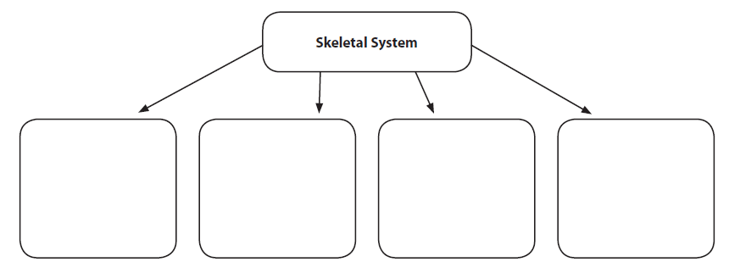

What does it mean to be a VOLUNTARY muscle? How is it different than an INVOLUNTARY muscle? __________________________________________________________________________________________________________________________________________________________________________________________________________________________________________________________________________________________________________________________________________________________________________________________________________________

