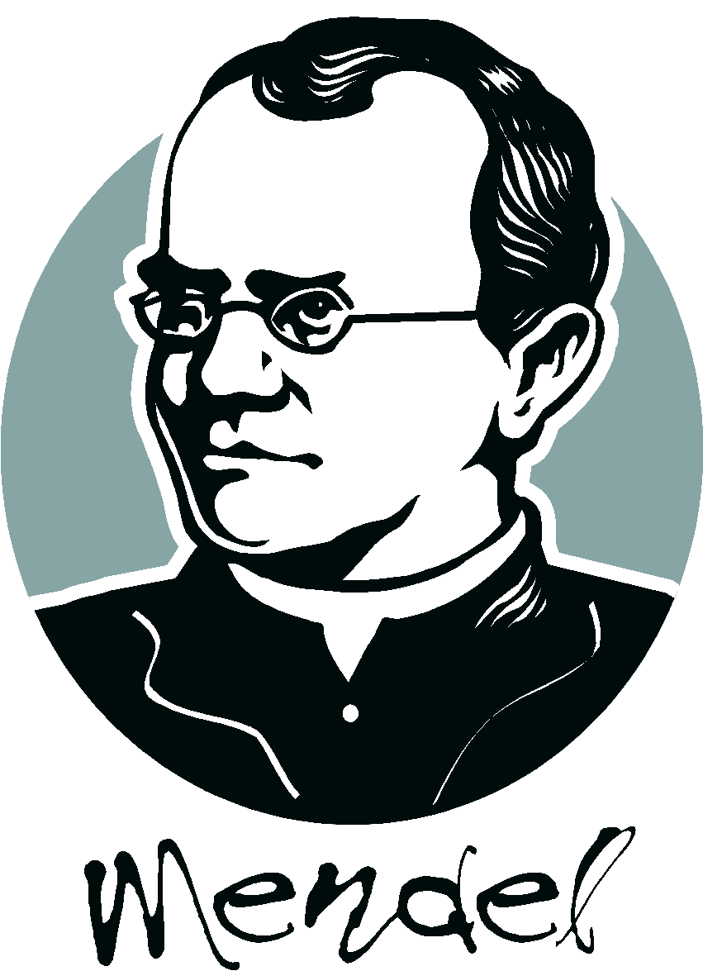

Mendel: Understanding Inheritance Name: _______________
Date:________________
Period:____________

What are TRAITS?
- Traits are ______________________________.

- For example, being ____________________________________.

- Traits are ______________ and are passed down from _____________________

______________________________.

Who was GREGOR MENDEL?

- Gregor Mendel was an Austrian monk, who lived in the ___________________.

- He conducted _________________ of experiments on ________________ to

see how _________________ were passed down from generation to generation.

- Mendel is known as the “_____________________________” for figuring out

the _________________________________________________________.

What type of experiments did Mendel do?

- Mendel crossed pea plants with different traits (eg. ____________________).

- He started with _____________________ plants (showed the same trait for many generations).

- He crossed a __________ parent with a ____________ parent.

Tall

Short

Tall

Tall

Tall

Short

Tall

Tall

The 1st generation of offspring were _________ ! In the 2nd generation, the lost short trait

The _____________ trait was ____________. ____________ in ____ of the offspring.

What are Mendel’s rules of inheritance?

- Mendel figured out that:

  - Traits are controlled by ______________ of “________________” that are

inherited from your __________________.

  - Some factors are “__________________” (they _______________ the other factor).
(For example, the dominant tall gene hides the recessive short gene in pea plants.)

New Vocabulary – VERY IMPORTANT!

- GENES - ___________________________________________________________.

- ALLELES - _________________________________________________________.
(the TALL and SHORT alleles are the 2 forms of the HEIGHT gene in peas).

- DOMINANT ALLELE – is one whose trait ___________________________________

________________________. It can _________________ the other form of the trait.

- It is shown with an ____________________ letter, for example “______”.

- RECESSIVE ALLELE – is one whose trait ___________________________________

____________________. It will only show up if ______________________________.

- It is shown with a __________________ letter, for example “______”.

- HOMOZYGOUS - Organisms with _______________________. (example - TT tt)

- HETEROZYGOUS - Organisms with ______________________. (example - Tt)

Let’s Review…
- When you cross a tall plant and a short plant, all the offspring get a dominant allele (T) from 1 parent; and a recessive allele (t) from the other parent.

Tt

TT

tt

TT

tt

Tt

Tt

Tt

- In the first generation, the _________________ allele hides the _______________ allele,

so ALL the offspring are _____________. They are all ______________________.

- In the second generation, the heterozygous plants cross and it’s possible to have a plant with

__________________________. With 2 recessive alleles, the plant will be _____________.

*SUMMARY: When studying genetics, we need to take 2 things into account:

- PHENOTYPE: An organism’s ___________________________________.

- GENOTYPE: An organism’s ____________________________________.

