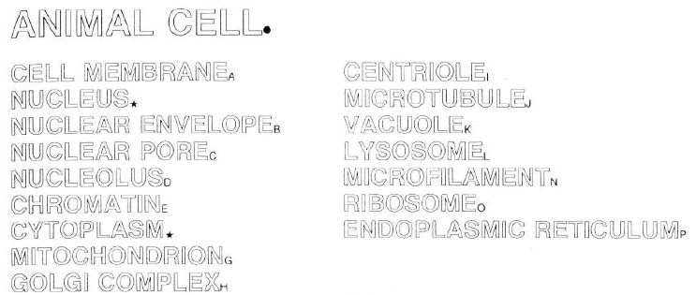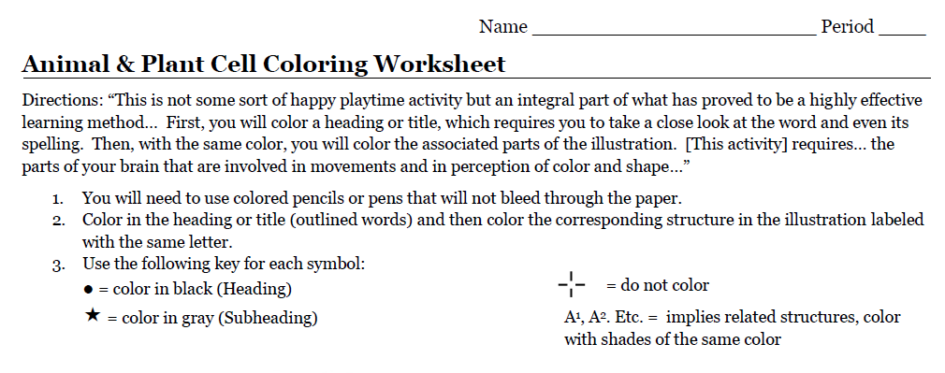

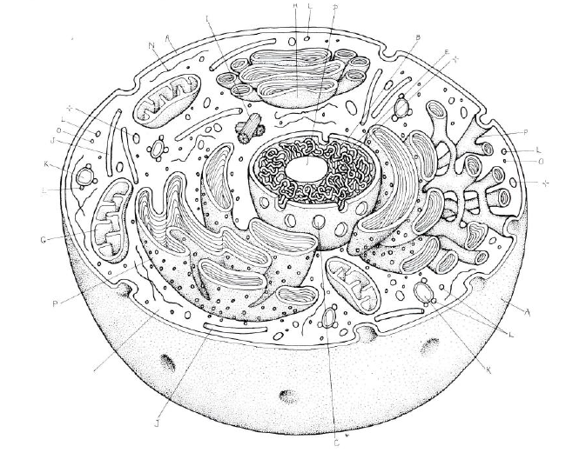

**A**

**H**

**D**

**P**

**O**

**L**

**O**

**K**

**G**

**P**

**L**

**K**

Organelles of the Animal Cell: Name:___________________________

Beside the given organelle (little organ) of the animal cell, write its function AND a comparison to a human body part or system. I want you to know what that little organ does to help the cell stay living (MRS NERG-C).

|  |  |  |
| --- | --- | --- |
| ***Organelle*** | ***Function*** | ***Comparison*** |
| Cell membrane |  |  |
| Nucleus |  |  |
| Cytoplasm |  |  |
| Mitochondria/mitochondrion |  |  |
| Golgi complex |  |  |
| Vacuole |  |  |
| Lysosome |  |  |
| Ribosome |  |  |
| Endoplasmic Reticulum |  |  |



**F**



**O**

**O**

**L**

**L**

**K**

**K**

**I**

**J**

**J**

**I**

**F**

**D**

**B**

**A**

Organelles of the Plant Cell: Name:___________________________

Beside the given organelle (little organ) of the animal cell, write its function AND a comparison to a human body part or system. I want you to know what that little organ does to help the cell stay living (MRS NERG-C).

|  |  |  |
| --- | --- | --- |
| ***Organelle*** | ***Function*** | ***Comparison*** |
| Cell membrane |  |  |
| Nucleus |  |  |
| Cytoplasm |  |  |
| Mitochondria/mitochondrion |  |  |
| Golgi complex |  |  |
| Vacuole |  |  |
| Lysosome |  |  |
| Ribosome |  |  |
| Endoplasmic Reticulum |  |  |
| Chloroplast |  |  |
| Cell Wall |  |  |
|  |  |  |
|  |  |  |